Java Promblemsheet - 4

Name: Kaaviya S S Roll. no: 22PT15

1. Write a program that uses String method to compare two strings input by the user. The application should input the number of characters to be compared and the starting index of the comparison. The application should state whether the strings are equal. Ignore the case of the characters when performing the comparison.

import java.util.Scanner;

public class CompareStrings {
public static void main(String[] args) {

Scanner obj = new Scanner(System.in);

System.out.println("Enter two strings: ");
String str1 = obj.nextLine();
String str2 = obj.nextLine();
System.out.print("Enter the search index: ");
int index = obj.nextInt();

if (compareStrings(str1, str2, index)) {
System.out.println("The strings are equal!");
}
else {
System.out.println("The strings are NOT equal!");
}

obj.close();
}

public static boolean compareStrings(String str1, String str2, int index) {
//creates a substring starting from that index
String s1 = str1.substring(index);
String s2 = str2.substring(index);
// Compare substrings ignoring case
return s1.equalsIgnoreCase(s2);
}
}

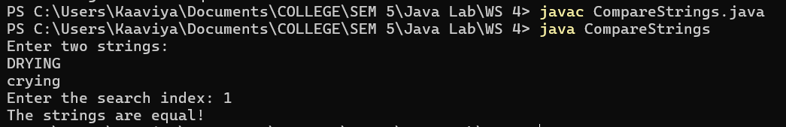

—----------------------------------------------------------------------------------------------------------------------------

2. Write a program that inputs a line of text, tokenizes the line with String method split and
outputs the tokens in reverse order. Use space characters as delimiters.

import java.util.Scanner;

public class ReverseTokens {
public static void main(String[] args) {

Scanner obj = new Scanner(System.in);

System.out.println("Enter a line of text: ");
String str = obj.nextLine();

//split into tokens
String[] tokens = str.split(" ");

System.out.printf("\nReversed tokens: \n");
for(int i=tokens.length-1; i>=0; i--) {
System.out.print(tokens[i] + " ");
}

obj.close();
}
}

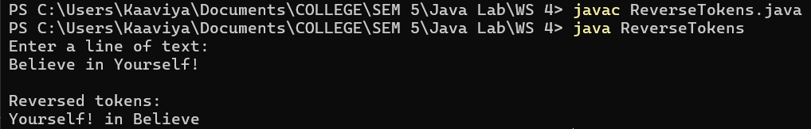

—----------------------------------------------------------------------------------------------------------------------------

3. Write an application that prompts the user for a password that contains at least two uppercase letters, at least three lowercase letters, and at least one digit. Continuously re-prompt the user until a valid password is entered. Display a message indicating whether the password is valid; if not, display the reason the password is not valid.

import java.util.Scanner;
import java.lang.Character;

public class ValidPassword {
public static void main(String[] args) {

Scanner obj = new Scanner(System.in);

boolean isValidPassword = false;
while(!isValidPassword) {
System.out.printf("\nEnter the password: ");
String password = obj.nextLine();

char[] passwordArray = password.toCharArray();
int digits=0, lowercase=0, uppercase=0;
for(char ch : passwordArray){
if(Character.isDigit(ch))
digits++;
else if(Character.isLowerCase(ch))
lowercase++;
else if(Character.isUpperCase(ch))
uppercase++;
else
continue;
}

if(uppercase < 2)
System.out.println("Password is not valid! Enter atleast 2 Uppercase charaters.");
else if(lowercase < 3)
System.out.println("Password is not valid! Enter atleast 3 Lowercase charaters.");
else if(digits < 1)
System.out.println("Password is not valid! Enter atleast 1 digit.");
else {
System.out.println("Password is valid!");
isValidPassword = true;
}
}

obj.close();
}
}

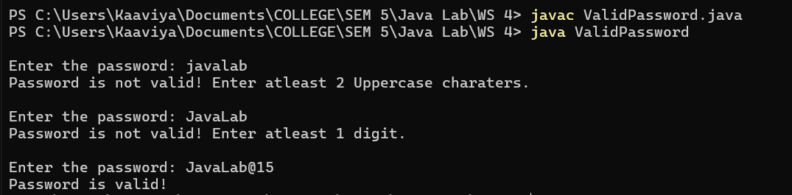

—----------------------------------------------------------------------------------------------------------------------------

4. Write a program in java to create a String object. Initialize this object with your name. Find the length of your name using appropriate String method. Find whether character ‘a’ is in your name or not, if yes find the number of time ‘a’ it appear in your name. Print locations of occurrences of ‘a’. Try same for different String object.

import java.util.Scanner;

public class StringOperations {
public static void main(String[] args) {

Scanner obj = new Scanner(System.in);

System.out.print("Enter the string: ");
String str = obj.nextLine();

int len = str.length();
System.out.print("Length of the string: " + len);

char targetChar = 'a';
boolean containsA = (str.indexOf(targetChar) >= 0);

if(containsA) {
System.out.printf("\ncharacter 'a' is present in the entered string!");
System.out.printf("\nOccurences of 'a': ");
int count = 0;
for(int i=0; i<len; i++) {
if(str.charAt(i)=='a'){
System.out.print(i + " ");
count++;
}
}
System.out.print("\nNo. of times 'a' appears: " + count);
}
else {
System.out.print("\ncharacter 'a' is NOT present in the entered string!");
}

obj.close();
}
}

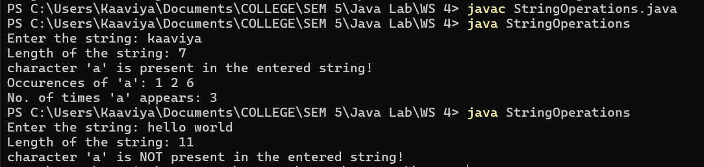

—----------------------------------------------------------------------------------------------------------------------------
5. An anagram is a word or a phrase made by transposing the letters of another word or phrase; for example, "parliament" is an anagram of "partial men," and "software" is an anagram of "swear oft." Write a program that figures out whether one string is an anagram of another string. The program should ignore white space and punctuation.

import java.util.Scanner;
import java.util.Arrays;

public class AnagramCheck {

public static void main(String[] args) {

Scanner obj = new Scanner(System.in);

System.out.println("Enter two strings: ");
String str1 = obj.nextLine();
String str2 = obj.nextLine();

//remove all the non-word char(digits, punctuation,...) from strings
//convert them to lowercase
String s1 = str1.replaceAll("[\\W]","").toLowerCase();
String s2 = str2.replaceAll("[\\W]","").toLowerCase();

//convert to char array
char[] charArray1 = s1.toCharArray();
char[] charArray2 = s2.toCharArray();

//sort them
Arrays.sort(charArray1);
Arrays.sort(charArray2);

if(Arrays.equals(charArray1,charArray2))
System.out.println(str1 + " and " + str2 +" are Anagrams!");
else
System.out.println(str1 + " and " + str2 +" are NOT Anagrams!");

obj.close();
}
}

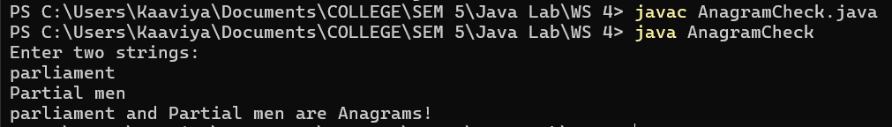

—----------------------------------------------------------------------------------------------------------------------------

6. Write program in Java for String handling which perform followings
i) Checks the capacity of StringBuffer objects
ii) Reverse the contents of a string given on console and convert the resultant string in uppercase
iii) Read a string from console and append it to the resultant string of ii.

import java.util.Scanner;

public class StringHandling {

public static void main(String[] args) {

Scanner obj = new Scanner(System.in);

// To Check the capacity of StringBuffer objects
StringBuffer strBuffer = new StringBuffer();
System.out.println("Initial capacity of StringBuffer: " + strBuffer.capacity());

// Reverse and uppercased string
System.out.print("Enter a string: ");
String str = obj.nextLine();
strBuffer.append(str);
strBuffer.reverse();
String reversed_uppercase_string = strBuffer.toString().toUpperCase();
System.out.println("Reversed and uppercased string: " + reversed_uppercase_string);

// final string after appending
System.out.print("Enter another string to append: ");
String anotherString = obj.nextLine();
StringBuffer finalString = new StringBuffer(reversed_uppercase_string);
finalString.append(anotherString);
System.out.println("Resultant string after appending: " + finalString.toString());

obj.close();
}
}

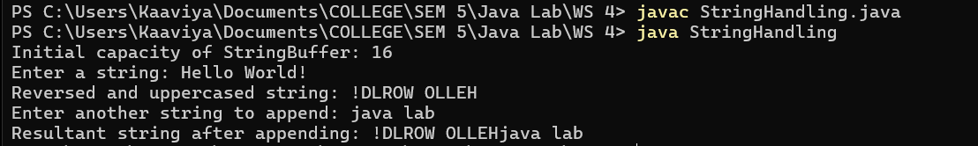

—----------------------------------------------------------------------------------------------------------------------------

7. Write a program that inserts parentheses, a space, and a dash into a string of 10 user-entered numbers to format it as a phone number. For example, 5153458912 becomes (515) 345-8912. If the user does not enter exactly 10 digits, display an error message. Continue to accept user input until the user enters 999.

import java.util.Scanner;

public class PhoneNumberFormat {

public static void main(String[] args) {

Scanner obj = new Scanner(System.in);

while (true) {
System.out.printf("\nEnter a 10-digit phone number (or 999 to exit): ");
String phoneNumber = obj.nextLine();

if (phoneNumber.equals("999"))
break;
else {
//to check if it is 10 digit number
if(phoneNumber.matches("\\d{10}")) {
String part1 = phoneNumber.substring(0,3);
String part2 = phoneNumber.substring(3,6);
String part3 = phoneNumber.substring(6,10);
System.out.println("Print Formatted Phone number: " + "(" + part1 + ") " + part2 + "-" + part3);
}
else
System.out.println("Please enter exactly 10 digits.");
}
}

obj.close();
}
}

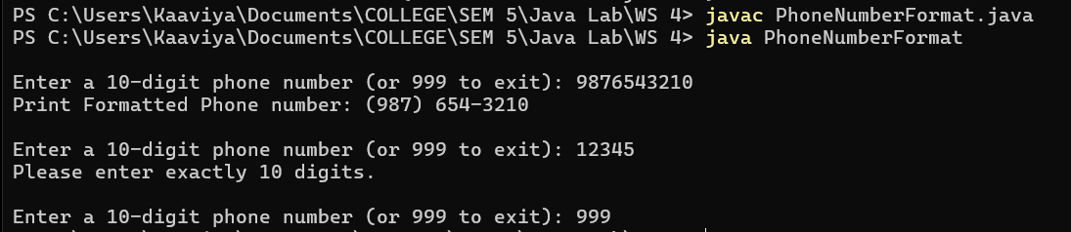

—----------------------------------------------------------------------------------------------------------------------------

8. Write an application that accepts a word from a user and converts it to Pig Latin. If a word starts with a consonant, the Pig Latin version removes all consonants from the beginning of the word and places them at the end, followed by ay. For example, cricket becomes icketcray. If a word starts with a vowel, the Pig Latin version is the original word with ay added to the end. For example, apple becomes appleay. If y is the first letter in a word, it is treated as a consonant; otherwise, it is treated as a vowel. For example, young becomes oungyay, but system becomes ystemsay. For this program, assume that the user will enter only a single word consisting of all lowercase letters.

import java.util.Scanner;

public class PigLatinConverter {

public static void main(String[] args) {

Scanner obj = new Scanner(System.in);

System.out.print("Enter a string: ");
String str = obj.nextLine();

System.out.println("Pig Latin word: " + PigLatin(str));
obj.close();
}

public static String PigLatin(String str) {
//check if 1st letter of str is a vowel
String vowels = "aeiou";
if (vowels.indexOf(str.charAt(0)) != -1) {
return str + "ay";
}

//if 1st letter is y --> treat it as consonant
if (str.charAt(0) == 'y') {
return str.substring(1) + "yay";
}

// If words starts with consonant
for(int i=0; i<str.length(); i++) {
char ch = str.charAt(i);
if( (vowels.indexOf(ch)!=-1) || ( i!=0 && ch=='y') ) {
return str.substring(i) + str.substring(0,i) + "ay";
}
}

//if no vowel
return str + "ay";

}
}
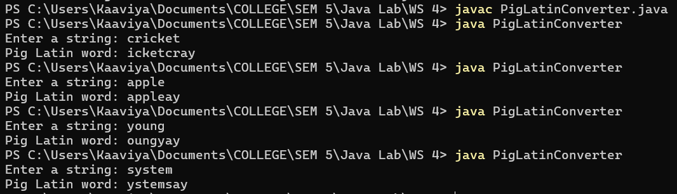

—----------------------------------------------------------------------------------------------------------------------------

9. Biologists use a sequence of the letters A, C, T, and G to model a genome. A gene is a substring of a genome that starts after a triplet ATG and ends before a triplet TAG, TAA, or TGA. Furthermore, the length of a gene string is a multiple of 3, and the gene does not contain any of the triplets ATG, TAG, TAA, or TGA. Write a program that prompts the user to enter a genome and displays all genes in the genome. If no gene is found in the input sequence, display “no gene is found”.

import java.util.Scanner;

public class GenomeModel {

public static void main(String[] args) {

Scanner obj = new Scanner(System.in);
System.out.print("Enter a genome sequence: ");
String genome = obj.nextLine();
findGenes(genome);

obj.close();
}

public static void findGenes(String genome) {
int pos=-1;
for(int i=0;i<genome.length()-3;i++)
{
if(genome.substring(i,i+3).compareTo("ATG")==0) {
pos=i+3;
i+=3;
}
if(pos!=0 && pos!=-1) {
if( genome.substring(i,i+3).compareTo("TAG")==0 || genome.substring(i,i+3).compareTo("TAA")==0 || genome.substring(i,i+3).compareTo("TGA")==0 ) {
if( (genome.substring(pos,i)).length()%3==0 ) {
System.out.println("Gene found: " + genome.substring(pos,i));
i+=3;
pos=0;
}
}
}
}
if(pos==-1) {
System.out.println("Gene is not found!");
}
}
}

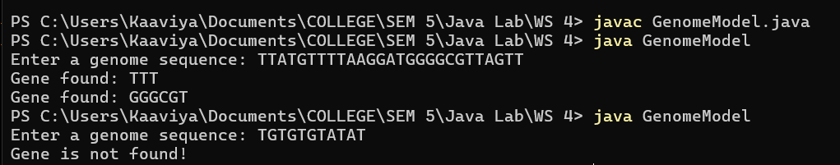

—----------------------------------------------------------------------------------------------------------------------------

10. Given an m x n grid of characters board and a string word. The word can be constructed from letters of sequentially adjacent cells, where adjacent cells are horizontally or vertically neighboring. The same letter cell may not be used more than once. Write a program the return true if word exists in the grid.
Example:
Input: board = [["A","B","C","E"],["S","F","C","S"],["A","D","E","E"]],
word = "ABCCED"
Output: true

import java.util.Scanner;

public class WordSearch
{
public static void main(String[] args)
{
Scanner obj = new Scanner(System.in);

System.out.print("No.of rows: ");
int m = obj.nextInt();
System.out.print("No.of columns: ");
int n = obj.nextInt();
char[][] mat = new char[m][n];
System.out.println("Enter the grid of characters: ");
for(int i=0; i<m; i++)
{
for(int j=0; j<n; j++)
mat[i][j] = obj.next().charAt(0);
}
System.out.print("Enter the word to search: ");

String word = obj.next();
System.out.println(findMatch(mat,word));

obj.close();
}

public static boolean findMatch(char[][] mat,String word)
{
int m = mat.length;
int n = mat[0].length;
for(int i=0; i<m; i++)
{
for(int j=0; j<n; j++)
{
if(DFS(mat,word,i,j,0))
return true;
}
}
return false;
}

public static boolean DFS(char[][] mat, String w, int i, int j, int index)
{
int m = mat.length;
int n = mat[0].length;

if(index == w.length())
return true;

else if(i < 0 || i >= m || j < 0 || j >= n || mat[i][j]!= w.charAt(index))
return false;

//mark as visited
char ch = mat[i][j];
mat[i][j] = '#';

boolean isFound = (DFS(mat,w,i+1,j,index+1) ||
DFS(mat,w,i-1,j,index+1) ||
DFS(mat,w,i,j+1,index+1) ||
DFS(mat,w,i,j-1,index+1));
//unmark
mat[i][j] = ch;

return isFound;
}

}

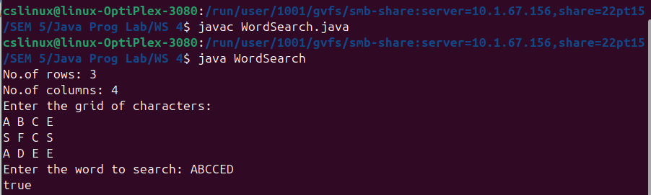

—----------------------------------------------------------------------------------------------------------------------------
11. Write a program to find the number of valid words in a given sentence. A sentence consists of lowercase letters ('a' to 'z'), digits ('0' to '9'), hyphens ('-'), punctuation marks ('!', '.', and ','), and spaces (' ') only. Each sentence can be broken down into one or more tokens separated by one or more spaces ' '.
A token is a valid word if all three of the following are true:
It only contains lowercase letters, hyphens, and/or punctuation (no digits).
There is at most one hyphen '-'. If present, it must be surrounded by lowercase
characters ("a-b" is valid, but "-ab" and "ab-" are not valid).
There is at most one punctuation mark. If present, it must be at the end of the token
("ab,", "cd!", and "." are valid, but "a!b" and "c.," are not valid).
Examples of valid words include "a-b.", "afad", "ba-c", "a!", and "!".
Given a string sentence, return the number of valid words in sentence.

import java.util.Scanner;
import java.util.regex.Pattern;

public class ValidWords {

public static void main(String[] args) {
Scanner obj = new Scanner(System.in);
System.out.print("Enter a string: ");
String str = obj.nextLine();

// Split sentence into tokens based on spaces
String[] tokens = str.split("\\s+");
int validWordCount = 0;

String regex = "^[.,!]$|^[a-z]+(-[a-z]+)?[.,!]?$";
// explaination for that regex
// either should contain exactly only one puncutation (or)
// start with lowecase, followed by hypen and lowecase(optionally) and end with exactly one punctuation(optionally)

for(String token: tokens) {
if(Pattern.matches(regex, token)) {
validWordCount++;
}
}

System.out.println("The number of valid strings : " + validWordCount);

obj.close();
}

}

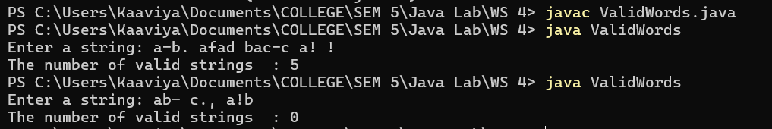

—----------------------------------------------------------------------------------------------------------------------------

12. The international standard letter/number mapping found on the telephone.
Write a method that returns a number, given an uppercase letter, as follows:
public static int getNumber(char uppercaseLetter)
Write a test program that prompts the user to enter a phone number as a string. The input number may contain letters. The program translates a letter (upper- or lowercase) to a digit and leaves all other characters intact.

import java.util.Scanner;

public class International_Telephone_Number {

public static void main(String[] args) {

Scanner obj = new Scanner(System.in);

System.out.print("Enter a string: ");
String phoneNum = obj.nextLine();

for(int i=0;i<phoneNum.length();i++) {
if(Character.isAlphabetic(phoneNum.charAt(i))==true)
System.out.print(getNumber(phoneNum.charAt(i)));
else
System.out.print(phoneNum.charAt(i));
}

obj.close();

}

public static int getNumber(char uppercase) {
char letter = Character.toUpperCase(uppercase);
if(letter >= 'A' && letter <= 'C')
return 2;
else if(letter >= 'D' && letter <= 'F')
return 3;
else if(letter >= 'G' && letter <= 'I')
return 4;
else if(letter >= 'J' && letter <= 'L')
return 5;
else if(letter >= 'M' && letter <= 'O')
return 6;
else if(letter >= 'P' && letter <= 'S')
return 7;
else if(letter >= 'T' && letter <= 'V')
return 8;
else if(letter >= 'W' && letter <= 'Z')
return 9;
else
return -1; //invalid
}
}





